Appendix C

FLOW OF THE SYSTEM

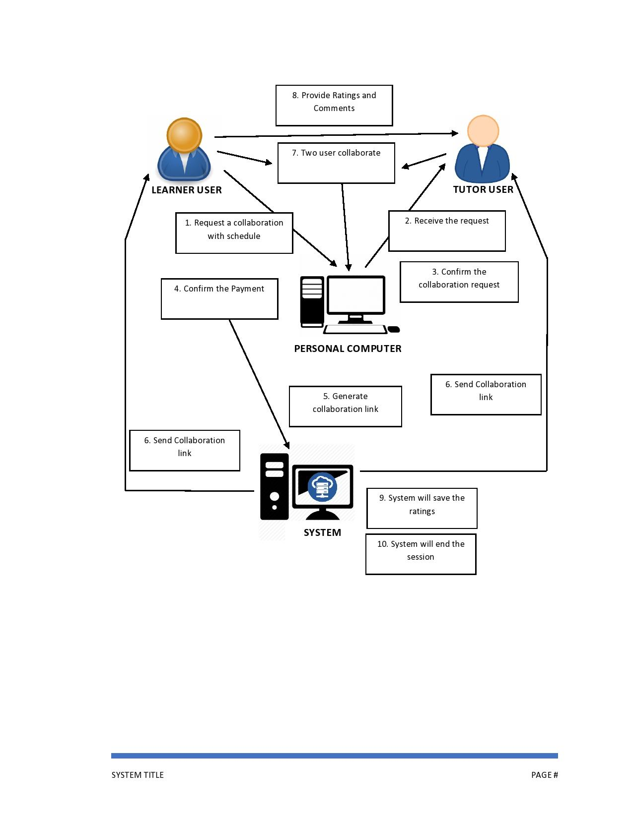Proposed Flow of the System

Figure #. The research methodology of the Proposed System

The illustration above exhibits the flow of interaction from the user to the system. The learner user will request a collaboration with the tutor user. Second, the tutor user will accept the collaboration of the learner user. Third, the learner user will pay the Tutor user for collaboration. Fourth, the system will automatically establish a generated link for the collaboration room and send an email notification to both users. Fifth, the two users will collaborate through the generated link and the system will end the session based on the schedule set up by the learner user. Lastly, the learner user will rate and comment on the tutor user about the collaboration.